Key word/idea | Explanation / further information… Bullet points
1. Where | South east Africa  surrounded by Mozambique Tanzania Zambia  main feature Lake Nyasa
2.  History | .1891 British protectorate Nyasaland  1964 independent  ..30 years one party Hasting Banda  1994 multi party elections  current president MUTHARIKA
3.Facts | ..area 118,480 sq km  .population 13,931,831  life expectancy 43.45 years  - Main exports: Tobacco, tea, sugar, cotton  - GNI per capita: US $250 (World Bank, 2007)
4. Problems | . Population growth  increasing pressure on agricultural lands  corruption  spread of HIV/AIDS
Name: Geographer
Source: http://news.bbc.co.uk/1/hi/world/africa/country_profiles/1068913.stm#facts

Name: MDG expert
Source: http://www.un.org/cyberschoolbus/mdgs/flash/index.asp
Key word/idea | Explanation / further information… Bullet points
1.Global  partnership  targets | . reduce tariffs and debts  increase aid  reduce the digital divide  increase access to medicine  .
2. developing countries must | . include rights for all citizens  improve public services  fight corruption  develop jobs for young people  .
3. rich countries  must | .provide more aid  .provide debt relief  .reduce tariffs and subsidies
4. progress so  far | .only 5 countries are giving 0.7% GNI to developing countries  . WTO has agreed a framework for ending farm subsidies  .13 of least developed countries have implemented poverty reduction programmes

Name: statistician
Source: http://www.mdgmonitor.org/country_progress.cfm?c=MWI&cd

Key word/idea | Explanation / further information… Bullet points
- achieving target  mdg | .insufficient evidence  .  .Internet users (per 100 people): 0.5
2.economy | Agricultural  85% population live in rural areas  1/3 gdp  90% exports  ½ exports = tobacco
3.debt | .2006 malawi approved for help under Heavily Indebted Countries Program.  .three year Poverty Reduction and Growth Facility worth $56 million with the IMF
4. government | .2005 Malawi began an anti-corruption campaign  .

Key word/idea | Explanation / further information… Bullet points
1.corruption | .February 2006, the DFID-funded Malawi Anti-Corruption Bureau (ACB) secured the first-ever conviction of a government minister on corruption charges.  ..
2.government | .DFID:has helped poor people realise their civil and political rights by providing US$22 million to enable them to work with civil society, the Malawi Parliament and the Malawi Electoral Commission to bring about a more accountable and responsible governance system  DFID supported (including funding) the development of a strategic plan for Parliament  .
.economy | .In 2007, growth exceeded 7% for the third year running.  The average settlement time for commercial disputes has decreased from 337 days in 2006 to 180 days in 2007.  ..
4.Scottish linked projects | sCOTTISH POLICE COLLEGE will work with the Malawian Police Service to determine what training is required to deliver community policing in Malawi.  .co-operative work can focus, and will recruit, train and brief two Scottish lawyers to work with the MLS to deliver a structured programme of legal support to a range of other legal organisations in Malawi.  .working with local NGOs to raise their capacity, using training and the production of locally based and themed publications. The project will host workshops for local NGOs focusing on advocacy strategies and sharing examples of successful lobbying campaigns, with the main emphasis on raising the position of women in local communities.  .
Name: Planner
Source: http://www.dfid.gov.uk/countries/africa/Malawi-facts.asp

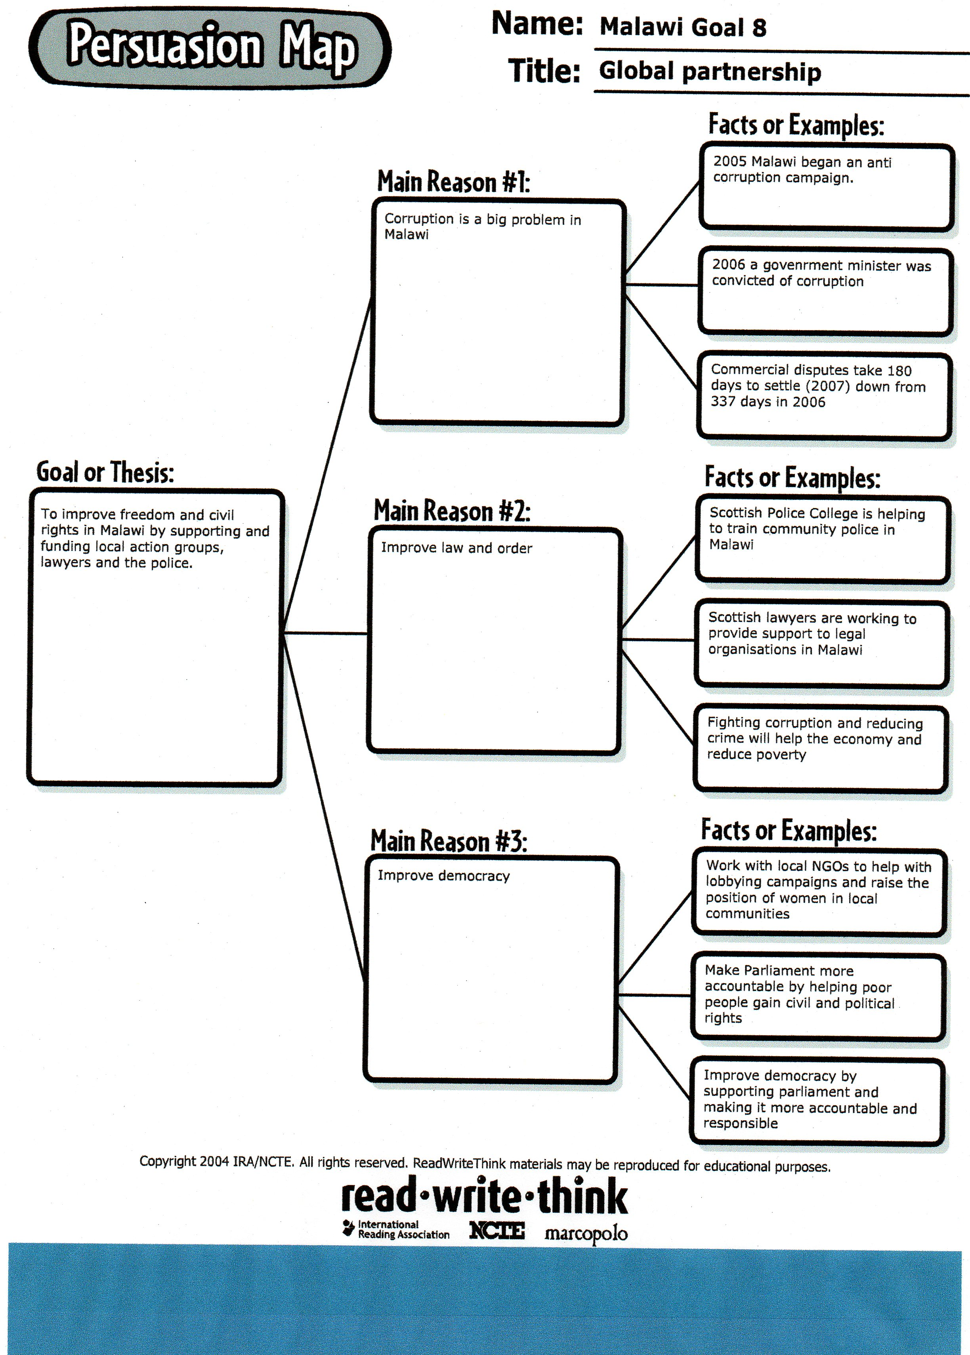

Websites

Author | Title | Date | URL  http://
CIA | World Fact Book | Online  4/3/09 | https://www.cia.gov/library/publications/the-world-factbook/geos/mi.html
UN | MDG Monitor | Online  4/3/9 | http://www.mdgmonitor.org/country_progress.cfm?c=MWI&cd
BBC News | Country Profile: Malawi | Online  2/3/9 | http://news.bbc.co.uk/1/hi/world/africa/country_profiles/1068913.stm#overview
UN CyberSchoolbus | Millennium Development Goals | Online  2/3/9 | http://www.un.org/cyberschoolbus/mdgs/flash/index.asp

